**RENTED VEHICLE MANAGEMENT SYSTEM**

**1) Registration**

Create And Insert:

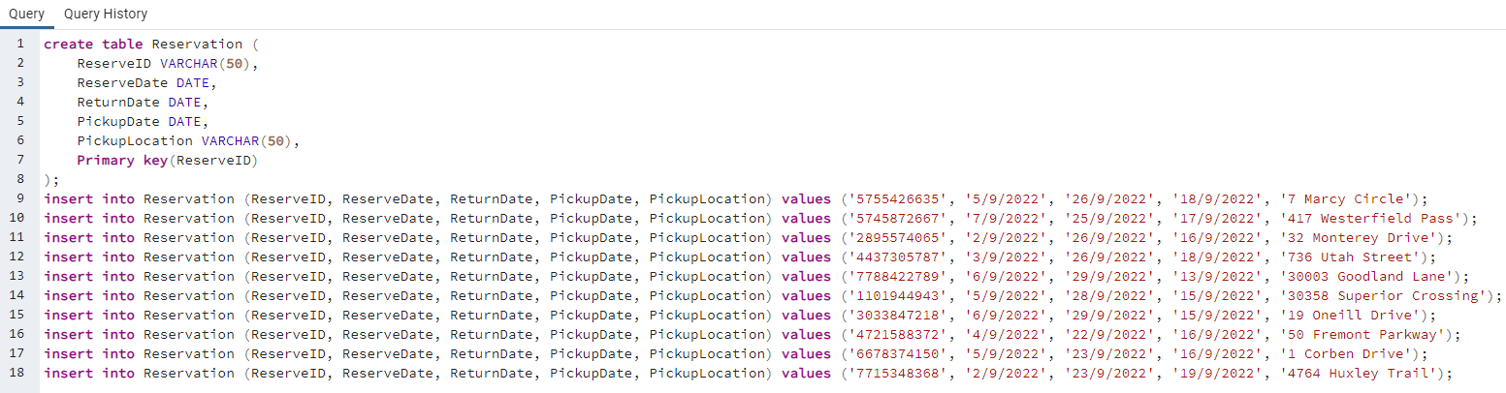

Output:

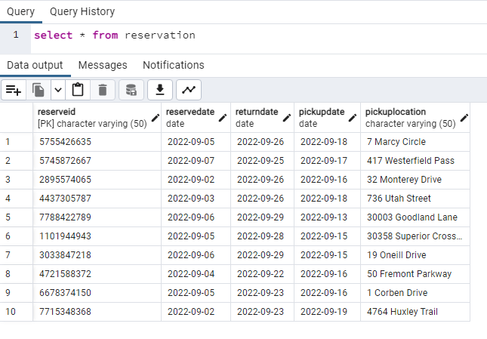

**2) Customer**

Create And Insert:

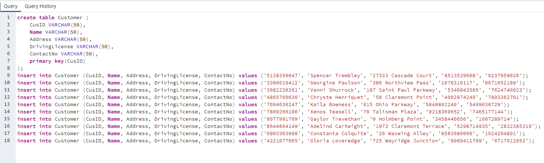

Output:

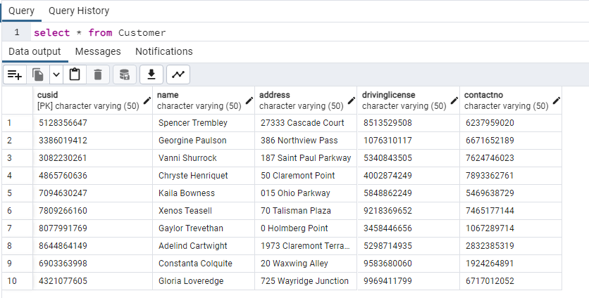

**3) Rent**

Create And Insert:

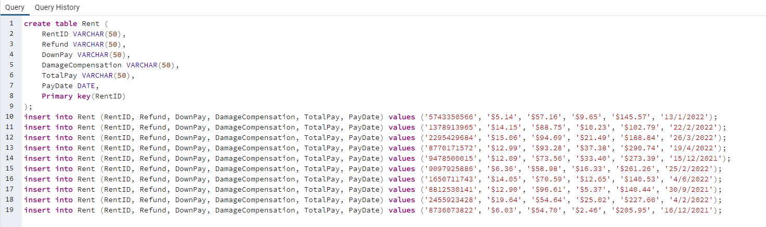

Output:

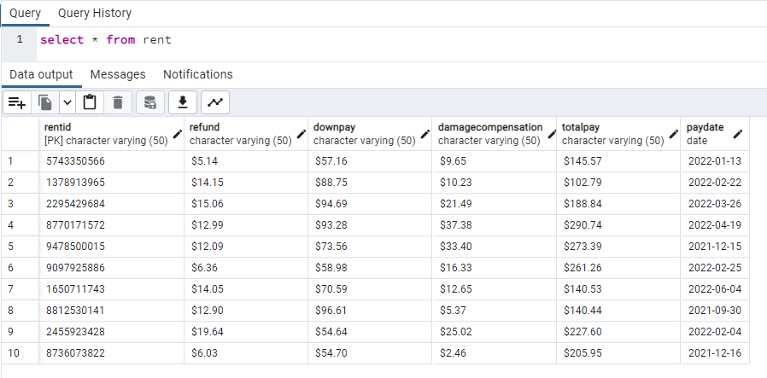

**4) Vehicle**

Create And Insert:

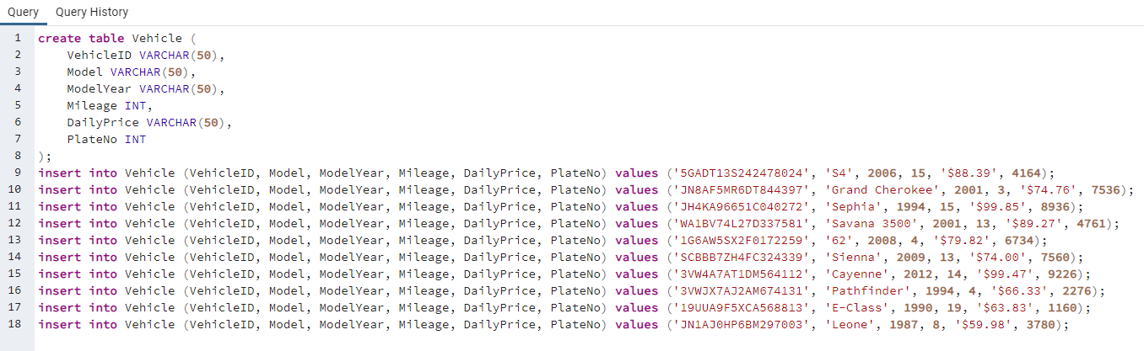

Output:

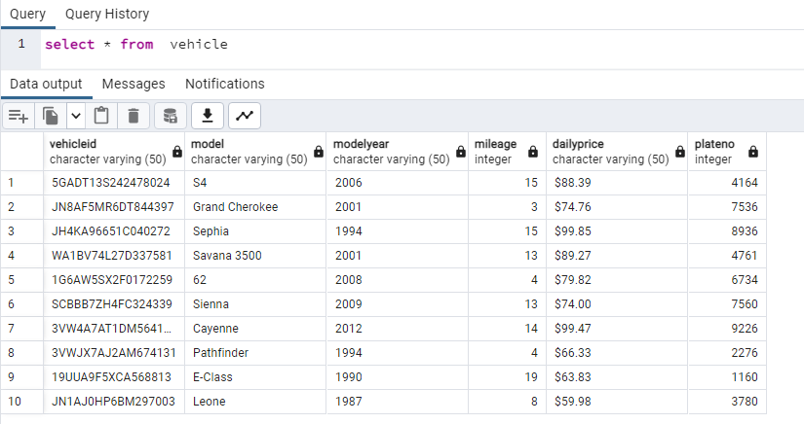

**5) Employee**

Create And Insert:

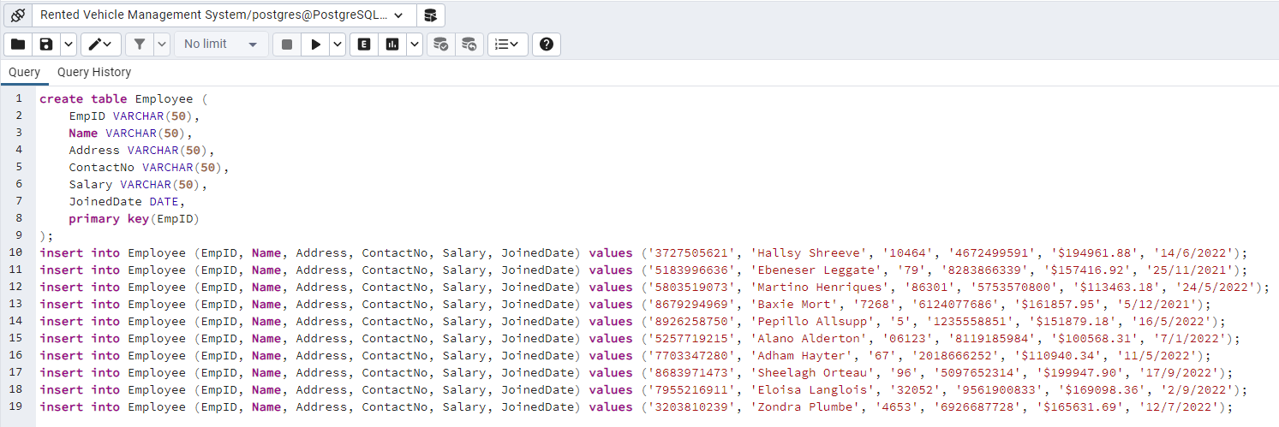

Output:

